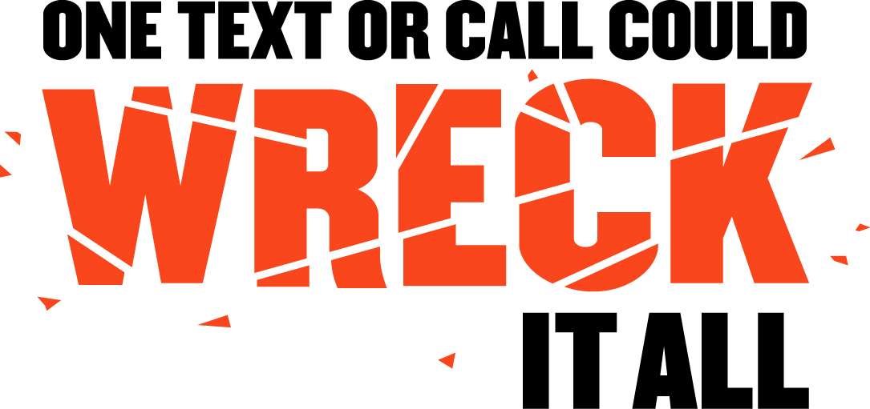

Parent-Teen Driving Contract

Young, inexperienced drivers, die too often in fatal crashes largely because of immaturity and inexperience. Three-stage GDL laws reduce these factors by gradually introducing driving tasks and privileges through controlled exposure to high-risk situations. All States and the District of Columbia have GDL laws with these three stages:
- Learner's Permit,
- Intermediate (Provisional) License, and
- Full Licensure

Make sure you and your teen drivers know and understand your State GDL laws before they get behind the wheel.

DISTRACTED DRIVING: In 2013, for drivers 15-19 years old involved in fatal crashes, 15 percent of the distracted drivers were distracted by the use of cell phones..

- RULE: NO CELL PHONES.

AGREEMENT: __________________________________________________________________________

CONSEQUENCES: ______________________________________________________________________

- EXTRA PASSENGERS: The risk of fatal crashes goes up in direct relation to the number of teens in the car. RULE: NO EXTRA PASSENGERS.

AGREEMENT: __________________________________________________________________________

CONSEQUENCES: ______________________________________________________________________

- SPEEDING: In 2013, speeding was a factor for 42% of teen (15-19) drivers in fatal crashes. RULE: NO SPEEDING.

AGREEMENT: __________________________________________________________________________

CONSEQUENCES: ______________________________________________________________________

- ALCOHOL: In 2013, 1,164 teen drivers were killed in motor vehicle traffic crashes. Twenty-five percent (289) of these drivers had alcohol in their system. RULE: ABSOLUTELY NO ALCOHOL!

AGREEMENT: __________________________________________________________________________

CONSEQUENCES: ______________________________________________________________________

- SEATBELTS: In 2013, almost half (49%) of teen (15-19) drivers of passenger car and light trucks killed in crashes were unrestrained. RULE: ALWAYS BUCKLE-UP.

AGREEMENT: __________________________________________________________________________

CONSEQUENCES: ______________________________________________________________________

TEEN: _____________________________________________________________________

PARENT/GUARDIAN: ________________________________________________________

DATE: ________________________________

